CUSTOM BEEF CUTTING
OUR LADY OF VICTORY FARMS
(315) 887-0322
PO BOX 335
VICTORY, NY 13033

Customer’s Name:
Telephone:
Address:

Chuck Roasts lbs.
Chuck Steaks inches # per pack
Rib Roast lbs. Bone in Yes/No
or
Rib Steak inches Bone In Yes/No
Short Rib
Stew Beef
Ground Beef
Soup Bones
Marrow Bones ______
Flank Steaks
Skirt Steak _____

Oxtail ______
Heart
Tongue
Liver
Kidney _______

Cow Weight:
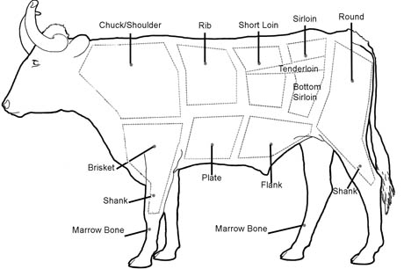

Date:
Email:
Whole: Half:
Split-half:

T-bone Steak inches
Porterhouse inches
OR
Strip Steaks inches
Tenderloins inches
Sirloin Steaks______inches

Rump/Rolled Roast lbs.

Round-
Steaks inches
Roast lbs.
Cutlets # per pack
Cube Steaks # per pack
Sirloin Tips-
Roast lbs.
Steaks inches

Total Price:

